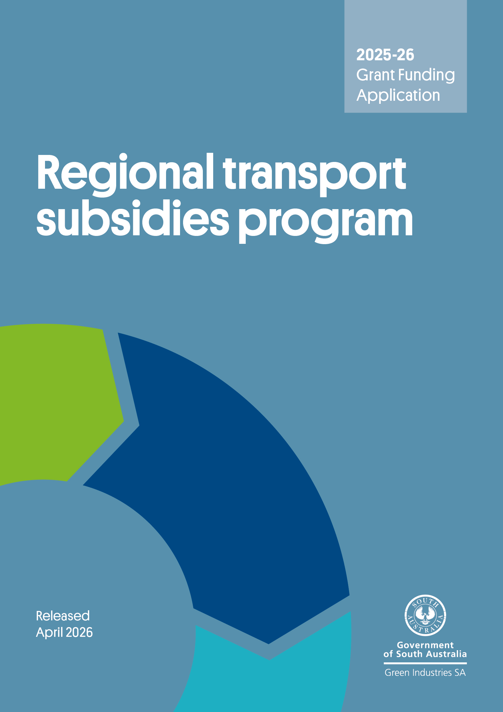

Background

The Regional Transport Subsidies Program provides temporary relief to support South Australian local councils in rural and regional areas to continue their kerbside recycling efforts and adapt to a challenging environment since implementation of China’s National Sword Policy in 2018.
All South Australian regional councils that provide yellow bin kerbside recycling services and transport collected material to recycling will have access to this temporary funding.
Submitting your application

Applications will be accepted until 5pm Adelaide time, 30 April 2026.

No late applications will be accepted.

Please email your completed application, including all supporting documents to:
Han.Tran@sa.gov.au with subject line ‘Regional Transport Subsidies Program’.
Emails should not exceed 10MB.

Checklist
Before submitting your application, please check you have completed all the following:
- Read the Regional Transport Subsidies Program Guidelines 2025-26 in detail.
- Completed the application form in full.
- Attached supporting evidence of the actual and forecast tonnage and transport distance.
- Attached copies of a Certificate of Currency for insurance (as required) and all other supporting documents.

Need assistance?
Email Han.Tran@sa.gov.au or call 0474 193 376 for more information and/or to check your eligibility.

Section A: Applicant information
A1. Applicant name (local council) and ABN
Name: ABN:
A2. Primary contact
Name: |  | Position:
Phone: |  | Email:
A3. Secondary contact
Name: |  | Position:
Phone: |  | Email:
A4. Insurance (please attach copies of the below Certificates of Currency).
- LGA Mutual Liability Scheme
- LGA Workers Compensation Scheme

Section B: Kerbside recycling processing information
B1. Please tick where applicable and provide relevant information
☐ Collection service provider |  |  | Name:
☐ Recycling processor |  |  | Name:
Contract term: |  |  | [DD/MM/20YY – DD/MM/20YY]
B2. Consolidation point location
(depot or collection point for kerbside recyclables prior to transport for processing)
Address:
B3. Recycling processing facility
Name: |  |  | Location:
Name: |  |  | Location:
B4. Transport distance
(Transport distance is measured one way from the consolidation point to the recycling destination. Where the consolidation point is outside council boundary, the distance between the main council chamber and the consolidation point can be included in the calculation)
Distance [km]:
B5. Waste transporter
Name:

Section C: Kerbside recycling estimation and funding amount

Please provide:
- actual tonnes of kerbside recycling for which you are requesting offset funds from the Regional Transport Subsidies Program and the associated travel distance (in kilometres) for the period of 1 July 2025 to 31 December 2025
- forecast tonnes of kerbside recycling for which you are requesting offset funds from the Regional Transport Subsidies Program and the associated travel distance (in kilometres) for the period of 1 January 2026 to 30 June 2026.

Kerbside recycling refers to total recyclable materials received by eligible local councils through a yellow bin kerbside collection service. The material types may include paper, cardboard, glass, metal and plastic.

The funding available per eligible council is calculated as follows:
Funding amount = total tonnes x non-metro kilometres travelled^{(a)} x subsidy rate^{(b)}

^{(a)} For the purpose of the program, kilometres travelled is measured one way from the consolidation point to the recycling destination. Where the consolidation point is outside the council boundary, the distance between the council chamber and the consolidation point can be included.
Non-metro kilometres travelled is determined by the kilometres travelled minus the average distance travelled by metro councils to the recycling destination. Under the 2025-26 program, the average distance travelled by metro councils is calculated at 16.5 kilometres. This is subject to annual review.

^{(b)} Subsidy rates are as follows:
Non-metro kilometres travelled | Subsidy rate ($ per tonne per km)
<150 km | $0.11
151 – 250 km | $0.13
251 – 400 km | $0.15
401 – 600 km | $0.17
>600 km | $0.20

Notes
- The distance of collection rounds will NOT be funded.
- The Regional Transport Subsidies Program is generally intended to provide funding support for one way transport of kerbside recyclables from regional council area up to Metropolitan Adelaide, however interstate transport will be considered on a case-by-case basis if sufficient justification is provided.

Kerbside recycling actual tonnage (tonnes)
Jul 25 | Aug 25 | Sep 25 | Oct 25 | Nov 25 | Dec 25 | Total

Kerbside recycling forecast tonnage (tonnes)
Jan 26 | Feb 26 | Mar 26 | Apr 26 | May 26 | Jun 26 | Total

Notes
- Applicants need to provide supporting evidence of the actual and forecast tonnage and transport distance.
- The forecast tonnages and transport distance will be reconciled with the actual tonnages and transport distance reported for the final payment.
Section D: Declaration and authorisation

Please note: The Chief Executive, or Chief Executive’s delegate of your organisation must sign the application form. It should not be signed by the contact person unless the contact person is the Chief Executive or delegate.
Declaration
- I/we have read and understood the Guidelines and obtained clarification where needed.
- I/we declare that the information provided in this application including attachments is true and correct and discloses all required and relevant details. I/we understand that if information supplied as part of the application is false or misleading in a material particular, the application will not be considered OR, if the grant is made and it is discovered that information supplied was false or misleading in a material particular, the grant will be revoked and funds, plus interest, must be repaid. An assessment regarding possible fraud will also be undertaken and appropriate legal action initiated if warranted.
- I/we declare that I/we have complied with federal and state laws, regulations and the Environment Protection Authority licences (if any).
- I/we authorise Green Industries SA to seek any additional relevant information required to process this application, and I/we hereby request and authorise any parties to supply such information as requested.
- I/we understand that if this application is approved for funding, information about the program may be publicised by Green Industries SA or provided as required or permitted by law.
- I/We understand if this application is approved for funding, a final report with evidence on actual tonnage of kerbside recyclables collected and transport distance as well as evidence that the collected recyclables was recycled and not unlawfully stockpiled must be received by Green Industries SA no later than 31 August 2026.
- I/We understand that the information provided in this application and in any reports required may be subject to an audit as outlined in the Funding Agreement.

Signed
Name
Position
Date

Recycling includes “activities through which wastes are collected, sorted, reprocessed (including through composting), and/or converted into raw materials for use in a production system, excluding for energy” as defined under the National standard for waste and resource recovery data and reporting (2021).
Examples of supporting evidence of the tonnage collected for recycling could be weighbridge dockets, invoices with quantities processed or collected, or emails from collectors or processors with quantities of kerbside co-mingled recyclables processed.
Examples of supporting evidence of actual transport distance could be an email from your collector to confirm travel distance and/or final destination(s), or invoices from collectors or processors to confirm final destination of kerbside co-mingled recyclables.

