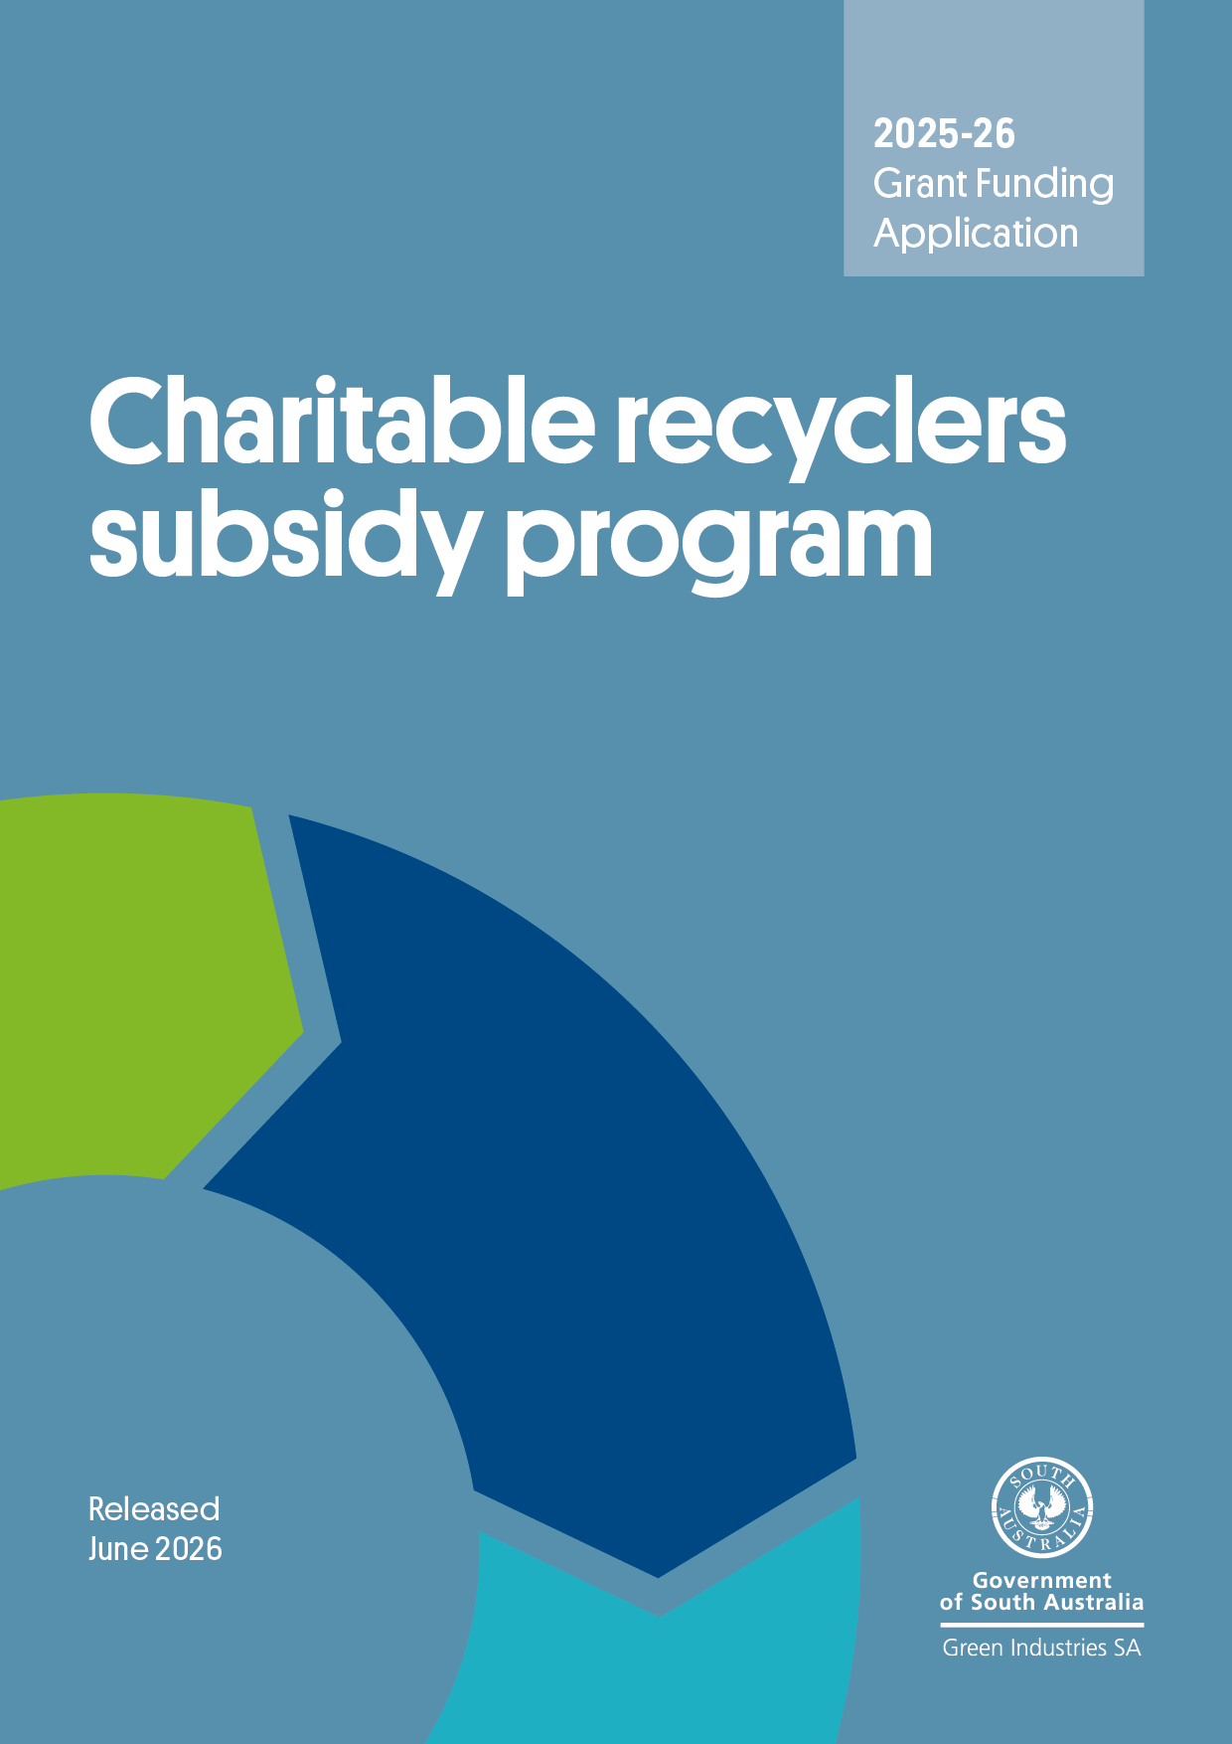


Background

The Charitable Recyclers Subsidy program enables eligible South Australian charitable recyclers to partially offset some of the landfill disposal costs associated with residual waste stemming from goods donated for the purpose of reuse, resell or recycle.
Further information on the program is contained in the program guidelines available on the Green Industries SA website.

Submitting your application
Please email your completed application form, claim form and supporting evidence to Han.Tran@sa.gov.au with subject line ‘Charitable Recyclers Subsidy Program – application’. Emails should not exceed 10MB.
Checklist
Before submitting your application, please check you have:
- read the Charitable Recyclers Subsidy Program Guidelines 2025-26 in detail
- completed the application form in full
- completed the claim form in full
- attached supporting evidence (such as invoices and weighbridge dockets) of waste collected/disposed.
Need assistance?
Contact Senior Projects Officer, Han Tran on +61 474 193 376 or at Han.Tran@sa.gov.au.

Instructions
- You can choose to submit an application for each claim period or submit one application for the full financial year in the second claim period.
- For the first claim period (July to December), please complete all sections in the application form.
- For the second claim period (January to June), if you have previously submitted your claim for the first claim period and there are no changes to the information previously provided under sections A & B, you can choose to complete sections C and D only.

Section A: Applicant Information
A.1. Name of organisation
Registered business name:
Trading name (if any):
A.2. Business registrations
Australian Business Number (ABN):
Australian Company Number (ACN):
A.3. Is your organisation registered for GST?
☐ Yes ☐ No
A.4. Business address
Street address:
Suburb: State: Postcode:
Postal address (if different from business address)
Street address:
Suburb: State: Postcode:
A.5. Primary contact details
Name: |  | Position:
Phone: |  | Email:

Section B: Eligibility details and organisational background
B.1. Eligibility criteria |  |  |  | Yes | No
1 | Is the applicant a not-for-profit organisation? |  |  | ☐ | ☐
2 | Is the applicant licensed under the South Australian Collections for Charitable Purposes Act 1939? |  |  | ☐ | ☐
3 | Has the applicant obtained Deductible Gift Recipient Status from the Australian Tax Office? |  |  | ☐ | ☐
4 | Where the answer to Question 3 is ‘No’, has the applicant obtained a letter of endorsement from a local government confirming the organisation is charitable and provides a service which benefits the community? |  |  | ☐ | ☐
5 | Does the applicant operate public drop-off points in South Australia where the community can donate items, such as charity bins or shops receiving items from the public? |  |  | ☐ | ☐
6 | Are collection activities undertaken by the applicant voluntary or not-for-profit and with no commercial interest? |  |  | ☐ | ☐
7 | Does the applicant have measures in place to discourage scavenging and dumping of waste?  If ‘Yes’, please provide more information on waste reduction measures (tick where applicable):  ☐Signs ☐CCTV ☐Fencing  ☐Security patrols ☐Others:________ |  |  | ☐ | ☐
8 | Does the applicant have paid employees and/or volunteers that are directly involved in the operation of the recycling program(s) including collection, sorting, retailing, exporting of used clothing and associated products or providing clothing to the public for charitable purposes and that is (or are) exclusively run to support the charitable purpose of the organisation? |  |  | ☐ | ☐
9 | Does the applicant sell or otherwise allow their brand name to be used by a commercial operator to solicit donated goods? |  |  | ☐ | ☐
10 | Has the applicant been actively involved in the consistent operation of a recycling and reuse program for a minimum of 12 months prior to seeking funds? |  |  | ☐ | ☐
B.2. Organisational background
How many FTEs does the organisation currently employ in South Australia?
How many volunteers does the organisation use in its operations in South Australia?
 |  | Metropolitan areas | Regional areas
Number of op shops (retail outlets)
Number of warehouses (sorting centres)
Number of donation bins

Section C: Details of subsidy and supporting information
C.1. Details of subsidy
Is this subsidy claimed for waste that has been collected for the purpose of disposal at a licensed landfill(s)? | ☐ Yes ☐ No
Claim Period: ☐ July – December 2025 ☐ January – June 2026
Have you completed and attached the claim form to this application? ☐ Yes ☐ No
1) Across all donations received
Please provide an estimated breakdown of where materials end up:
Reuse or sell (%) | Sent for recycling (%) | Landfill disposal (%) | Total
 |  |  | 100%

2) Landfill disposal
Please provide an estimated composition of general waste collected for landfill disposal:

Waste type | Estimated %
Clothing/textiles
Kitchenware
Furniture
Toys
Books/publications
Others
Please specify, if possible:
Total | 100 %

C.2. Supporting documentation
Please provide supporting documentation, such as waste collection company invoices and weighbridge dockets (self-haul only), and so on, that may include the following information:
- Quantity of residual waste collected/disposed for which a subsidy is claimed
- Date of collection/disposal
- Name of the entity that collected/disposed of the waste
- Name of the EPA licensed landfill(s) to which the waste was disposed (if known)
- Total cost of waste disposal (levy component separated out if possible)
Did you attach supporting documentations in the application? | ☐ Yes | ☐ No

Section D: Declaration
I certify that to the best of my knowledge the statements made in this application are true.

Signature
Name
Position
Date

Please note: The Chair, President or Chief Executive, or authorised delegate of your organisation must sign the application form. It should not be signed by the contact person unless the contact person is the Chief Executive or delegate.

