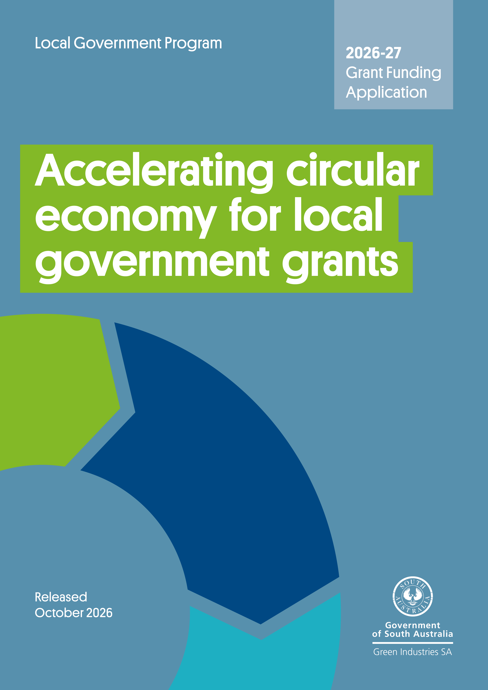

Contents
Program overview 3
Submitting your application 3
Need assistance? 3
Section A: General applicant information 5
Section B: Eligibility criteria checklist 6
Section C: Project proposal 7
Section D: Response to assessment criteria 10
Section E: Declaration 16
Appendix A – Guidance on risk assessment (guide for applicants) 18

Acknowledgement of Country
Green Industries SA acknowledges and respects the Traditional Custodians whose ancestral lands we live and work upon, and pays respect to their Elders past, present and emerging.
We acknowledge and respect their deep spiritual connections, and the relationship that Aboriginal and Torres Strait Islander people have to Country.
We extend our respect to all Aboriginal and Torres Strait Islander peoples and their nations in South Australia, and across Australia.

Program overview
The purpose of the Accelerating Circular Economy (ACE) for Local Government grant program is to encourage South Australian councils to increase implementation of circular economy principles and improve waste management and recycling services through the introduction of innovative initiatives, strategies, actions and approaches. The initiatives supported through the program should result in operational efficiencies, improved customer service and economic development benefits for the community and align with Accelerating SA’s transition to a circular economy: South Australia’s waste strategy 2025–2030.
Please refer to the Guidelines on the ACE for Local Government grant program webpage when preparing your application.

Submitting your application
Applications will be accepted until 5 pm ACDT, 4 December 2026.
Late applications will not be assessed.
Please email your completed application form, including a signed declaration, with all supporting documents to han.tran@sa.gov.au with the subject line ‘ACE for Local Government Grants 2026-27 – application – [applicant name]’.
Emails should not exceed 10MB and applications are to be no more than 20 pages (including supporting information). To reduce file size, the first 3 pages of this form may be deleted before submitting to GISA.
Before completing your application:
- Read the grant funding guidelines in detail. The guidelines have important information regarding eligibility, the application and assessment process, and funding conditions.
- Complete all relevant sections of the application form.
- Attach and clearly number evidence in support of the application.
- Understand that applying does not guarantee funding approval. Your application will be assessed for eligibility and alignment with assessment criteria published in the grant guidelines. Funds are awarded at the discretion of Green Industries SA (GISA), and in accordance with budget availability for applications that satisfactorily meet all eligibility criteria and pass assessment criteria.

Need assistance?
For further information, or to discuss your application and eligibility, contact Justin Lang at justin.lang@sa.gov.au or on 0419 948 931.

Section A: General applicant information
A1. Name of organisation
A2. Australian Business Number (ABN)
A3. Is your organisation (tick one):
The lead organisation of a consortium or partnership?  If you are applying as the lead partner in this application, please provide details of other organisations in the project and their roles in Section A6. |  |  | The sole applicant?
A4. Applicant address and postal address
Street address:
Suburb: State: Postcode:
Your postal address (if different from your business address)
Street address:
Suburb: State: Postcode:
Website:
A5. Contact details:
Primary contact details: Person within the applicant organisation who will manage/oversee project delivery.
Full name: |  | Position:
Tel: |  | Mobile:
Email:
Secondary contact details: Person within the applicant organisation who will support project delivery.
Full name: |  | Position:
Tel: |  | Mobile:
Email:
A6. Name of partner organisation/service providers/contractors for this application (if any)
Partner/service provider/contractor 1
Name:
Address:
Email:
Role in the project:
Partner/service providers/contractor 2 (Add/delete rows as required)
Name:
Address:
Email:
Role in the project:

Section B: Eligibility and assessment criteria checklist
Applications that do not meet the below criteria will not be assessed further.
To be eligible for funding the applicant must meet all eligibility criteria below | Yes | No
B1. Is the applicant a council or local government subsidiary established under the Local Government Act 1999 (SA)? | ☐ | ☐
B2. Is the applicant currently solvent, able to enter into a legally binding funding agreement with the Government of South Australia and expected to remain solvent for the duration of the agreement? | ☐ | ☐
B3. Does the applicant comply with all federal and state laws, regulations and any applicable Environment Protection Authority requirements? | ☐ | ☐
B4. Does the proposed project meet and contribute to the objectives and aims of Accelerating SA’s transition to a circular economy: South Australia’s waste strategy 2025–2030 and the ACE for Local Government Grants for 2026-27. | ☐ | ☐
B5. Does the proposed project demonstrate the need for government funding for at least one of the ACE for Local Government Grants program priority areas as listed below?  - Contamination detection and reduction  - Using technology and innovation to improve service delivery  - Development of circular roadmaps, waste management plans and strategies  - If none of the above, is it aligned with ‘other eligible projects’ in the Guidelines. | ☐  ☐  ☐  ☐ | ☐  ☐  ☐  ☐
B6. Will the project outcomes provide a measurable economic, environmental, or social benefit to South Australia? | ☐ | ☐
B7. Does the project have a clear implementation timeframe and milestones? Will the project be delivered within the required timeframe? | ☐ | ☐
B8. Does the project involve new activities which have not been commenced previously by the applicant? | ☐ | ☐
B9. Does the project have an experienced project manager assigned to oversee project delivery? | ☐ | ☐

Section C: Project proposal
C1. Project title
If your application is successful, this title or a variation thereof may be used by GISA for promotional and/or reporting purposes
C2. Project timeframe
Proposed start date: | Expected completion date:
C3. Project location (if different from A4)
C4. Key project aim
C5. Project summary
Please provide a brief overview of the project, highlighting what the project is and what it aims to do (maximum 100 words). This summary may be used by Green Industries SA for promotional purposes
C6. Project details and rationale
Describe the project in more detail, including why it is needed, what specific objectives it seeks to achieve, and the expected outcomes – particularly economic, environmental, or social benefits.
C7. Project type
☐ Contamination detection and reduction
☐ Use of technology and innovation to improve service delivery
☐ Development of circular roadmaps, regional waste management plans and strategies
☐ Other (please specify)

C8. Project budget and funding
List items required for the project (excluding in-kind contributions, these should be added to the next table).
Funding from Green Industries SA is available as a co-contribution of up to 50% of the total project costs from sources other than the South Australian and Australian governments and not including ‘in-kind’ (non-financial), up to a maximum of $100,000 per proponent.

Applicants eligible for a reduced co-contribution may request funding of over 50% total project costs where sufficient justification and supporting evidence can be demonstrated.

Please include detailed quotes for any goods and services to be procured where applicable, noting quotes must include suppliers’ details including ABN and any GST component.

Project activity  (expenditure item) | Delivery date  (estimated) | GISA funding sought  ($) | Applicant contribution  ($) | Total cost of project  ($) (ex GST)
Totals (sum of amounts above the line) |  | $ | $ | $
% Total cash funding |  | % | % | %

Other funding source
Any other grants or funding that the applicant, partners, and sub-contractors for this application have or will receive relating to the activities proposed in this project.
Project activities/element | Organisation providing other funding/payment |  | Contact details for organisation | Amount of funding/payment |  | Relationship to this project
 |  |  |  | $
 |  |  |  | $
Please provide a breakdown of any in-kind contributions
Project element |  | Organisation providing in-kind contribution |  |  | Value of in-kind contribution
 |  |  |  |  | $
 |  |  |  |  | $
 |  | Total value of in-kind contribution |  |  | $
 |  | Total project budget |  |  | $

Section D: Response to assessment criteria

Project assessment criteria (weighted criteria)

D 1. Benefits of the initiative
Summarise the operational, environmental and/or community impacts arising from the project and attach supporting evidence.

Summarise any anticipated economic development benefits such as business expansion, supply chain benefits and/or employment growth and attach supporting evidence.
If applicable, summarise any community consultation or other stakeholder engagement processes that have been undertaken to inform the proposed project.

D 2. Project viability
Summarise the business case (and attach more detailed documents) to demonstrate how the project will result in any of the following criteria:
- Economic development benefits
- Reduced costs and/or more efficient and effective services
- Improved services within the community
- Improved circular economy in South Australia

D 3. Alignment with priority areas for 2026-27 programs
Demonstrate how the project aligns with the priority areas for this program and/or support the delivery of action in the Accelerating SA's transition to a circular economy: South Australia's waste strategy 2025–2030

D 4. Value for money
How are grant monies leveraged with other funding? Is there an existing budget allocation for this project?

Non-weighted assessment criteria
D 5. Assessment criterion: Capacity and capability to manage the project
- (a) Explain and demonstrate your organisation’s capacity and capability to manage and deliver the project successfully with sufficient commitment and experience, including:
- detailing how your organisation will manage the project, internal resourcing and relevant experience
- indicating the anticipated roles of sub-contractors and how they will be managed (if you intend to use sub-contractors).
Key people involved in the project (please add additional rows if necessary)
Name: | Position
Role in this project and relevant experience/expertise

Name: | Position
Role in this project and relevant experience/expertise

Information on sub-contractors and/or other organisations involved (if applicable)
- Describe the capacity of your organisation to implement the project successfully, such as financial viability, any supporting partnerships, and an understanding of the relevant regulatory requirements.

D 6. Project timeframe and milestones
Please outline project milestones and key activities (add more rows as required)
Milestone and key activities | Start date  (dd/mm/yy) | Completion date  (dd/mm/yy)
Milestone title:
Key tasks/activities:

Milestone title:
Key tasks/activities:

Milestone title:
Key tasks/activities:

D 7. Monitoring and evaluation
Please list project key performance indicators (KPIs) and/or deliverables, how they will be measured (what data will be captured/what’s the unit of measurement) and a target (goal) for each in the table below.

KPI/deliverables | How it will be measured | Target

D 8. Approvals
If your application is successful, you will need to provide details of an appropriate organisational approval (e.g. council resolution) and reports within 3 months of receiving the initial notification or within 3 months of the signing of the grant agreement, and before grant funds are released.

If already obtained, please attach a copy.

Does your project require any other council, state or federal government approvals? If yes, what are these, and have the approvals been obtained/when are they likely to be obtained?

D 9. Intellectual property
What Intellectual property will be created through this project? How will it be shared with GISA and/or other relevant stakeholders? Please specify any conditions or limitations on how the intellectual property may be used or shared (if applicable).

Project risk management (refer to Appendix A: Guidance on Risk Assessment on the program webpage)
D 10. Project risk management
Please identify and describe the key risks associated with the project, along with the proposed mitigation measures. For guidance on likelihood, consequences, and risk ratings, refer to Appendix A: Guidance on Risk Assessment on the program webpage. (Add more rows as required)
 | Risk short name | Risk description | Likelihood | Consequences | Inherit risk rating | Control/mitigation strategy | Residual likelihood | Residual consequences | Residual risk rating
1
2
3
4
5
6

Section E: Declaration

Application checklist

☐ | Completed all relevant sections of the application form in full
☐ | Included detailed quotes for any goods and services to be procured, noting quotes must include suppliers’ details including ABN and any GST component
☐ | Attached all supporting documents, such as council approval or resolution documents, if applicable
☐ | Included identification of the main risks associated with the project and the proposed mitigation measures (demonstrating appropriate project risk management)
☐ | Included appropriate key performance indicators, and information on their measurement, evaluation and data capture
☐ | Confirmed in your application whether details are finalised or subject to council consent, if applying for part funding toward a regional coordinator position.
☐ | Signed the declaration (ensuring it is signed by an authorised officer)

Supporting information
Please indicate the documentation attached in support of your application
Information supplied | Yes | No | N/A | Attachment No.
Business plan/business case
Project management plan
Cost estimates/quotes for proposed technology, infrastructure, or professional consultancy service/s
Market research/community impact analysis
Data analysis, economic modelling or other evidence to support assumptions
Other (specify)

Declaration
- I have read and understood the guidelines and obtained clarification where needed.
- I declare that the information provided in this application including attachments is to the best of my knowledge true and correct and discloses all required and relevant details. I understand that if information supplied as part of the application is false or misleading in a material particular, the application will not be considered OR, if the grant is made and it is discovered that information supplied was false or misleading in a material particular, the grant will be revoked and funds must be repaid. An assessment regarding possible fraud will also be undertaken and appropriate legal action initiated if warranted.
- I declare that I/we have complied with federal and state laws, regulations, and the Environment Protection Authority licences (if any).
- I authorise Green Industries SA to seek any additional relevant information required to process this application, and I/we hereby request and authorise any parties to supply such information as requested.
- I understand that if the project is approved for funding, information of a non-sensitive and non-confidential nature about the project may be publicised by Green Industries SA or provided as required or permitted by law.
- If the project is approved for funding, I will obtain all necessary and appropriate clearances from the relevant federal, state or local governments before executing the grant agreement and undertake to manage the proposed project in accordance with relevant laws and regulations.
- I understand that submission of this application does not guarantee funding approval and that all applications are assessed by Green Industries SA against the assessment criteria, with funds allocated in accordance with assessment results and budget availability.
- If I accept an offer of funding, then I accept (jointly and severally in the case of a group application) responsibility for administering grant funds and liability in the event grant funds are to be repaid.
This declaration must be signed by an appropriately authorised representative of the applicant organisation, such as the Chief Executive, Executive Officer, Chairperson, or equivalent.
The signatory must hold sufficient authorisation to ensure the applicant complies with the points listed above and is able to approve/enter into an agreement with Green Industries SA should the application be successful.

Signed
Name
Position
Date

Total project budget is the total cost of the project plus in-kind contributions

